Sauny
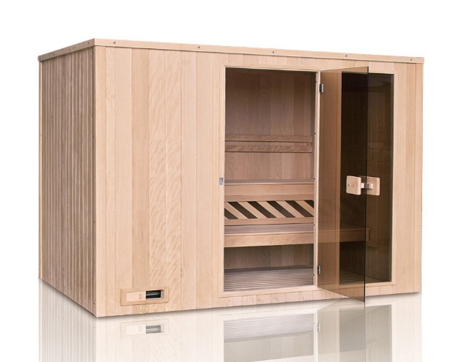
Model M003
198x170x198cm

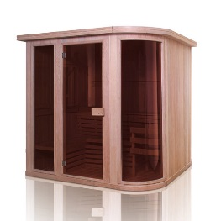
Model M004
198x170x198cm

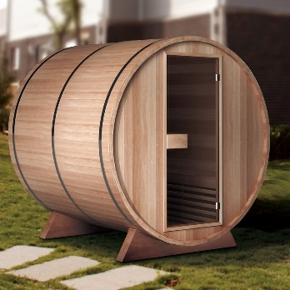

Model M005
180x190x180cm

www.abcbath.com Tel:222553531 Tel:506607194

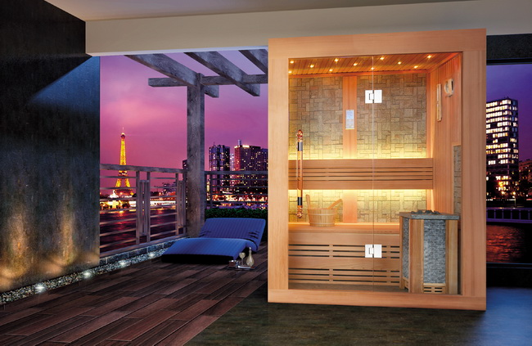
Model M001
100x110x190cm
120x110x190cm
150x110x190cm

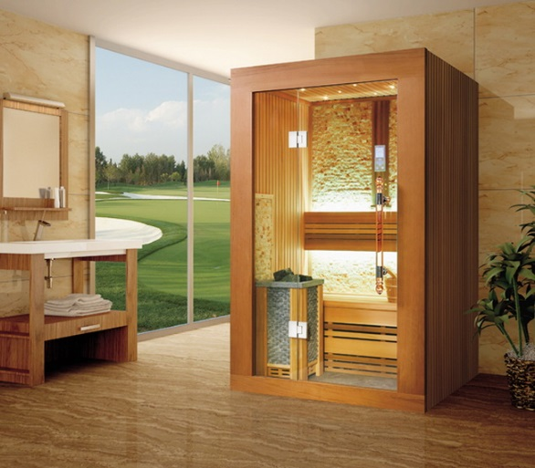
Model M002
100x110x190cm
120x110x190cm
150x110x190cm

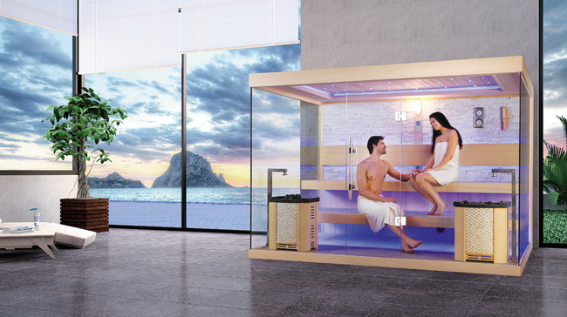
Model M003
200x180x210cm
220x180x210cm
250x180x210cm
280x200x210cm
300x200x210cm

www.abcbath.com Tel:222553531 Tel:506607194
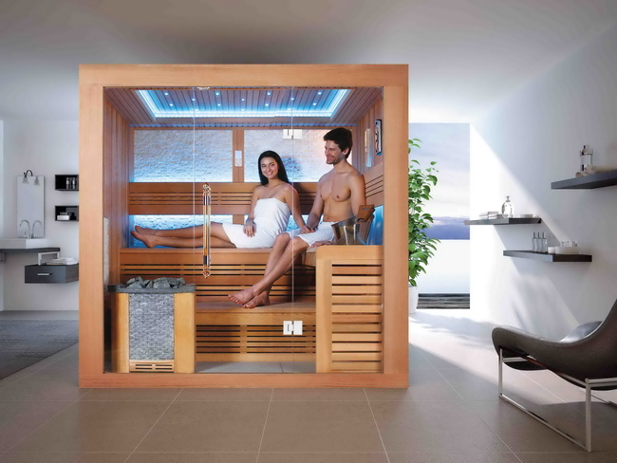
Model M004
200x180x210cm
220x180x210cm

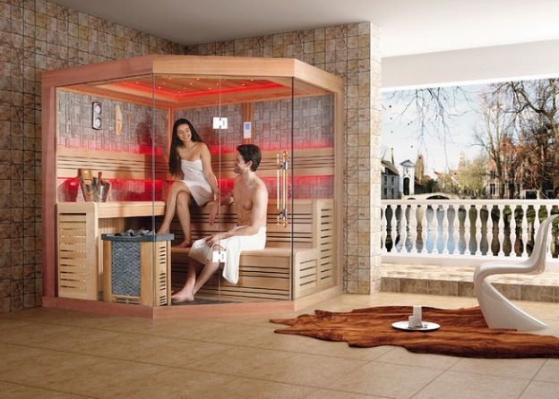

Model M005
200x200x210cm
220x200x210cm

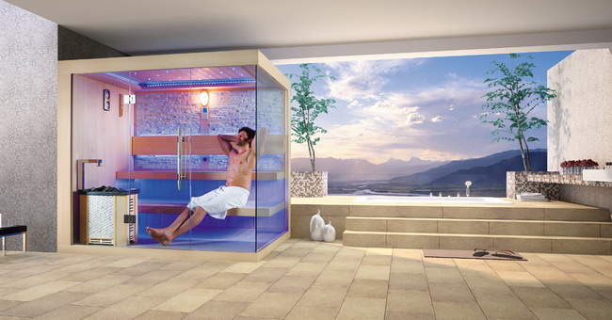
Model M006
200x180x210cm
220x180x210cm

www.abcbath.com Tel:222553531 Tel:50660719

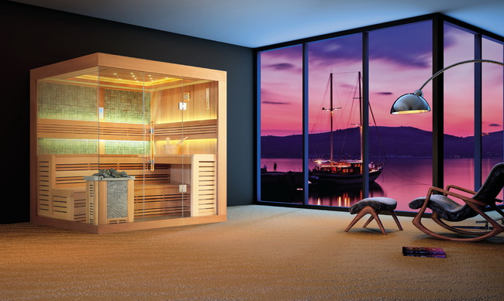
Model M007
200x180x210cm
220x180x210cm

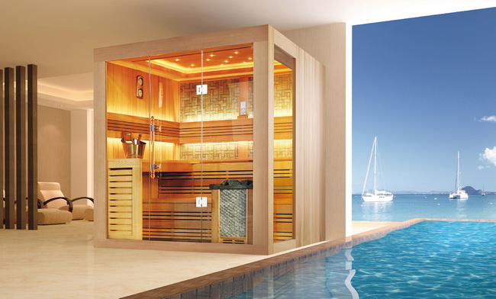
Model M008
200x180x210cm
220x180x210cm

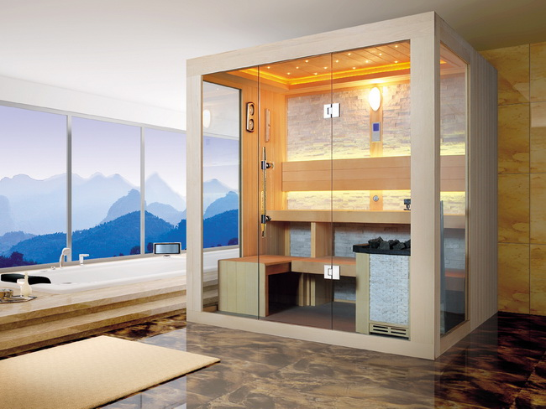
Model M009
200x180x210cm
220x180x210cm

www.abcbath.com Tel:222553531 Tel:506607194
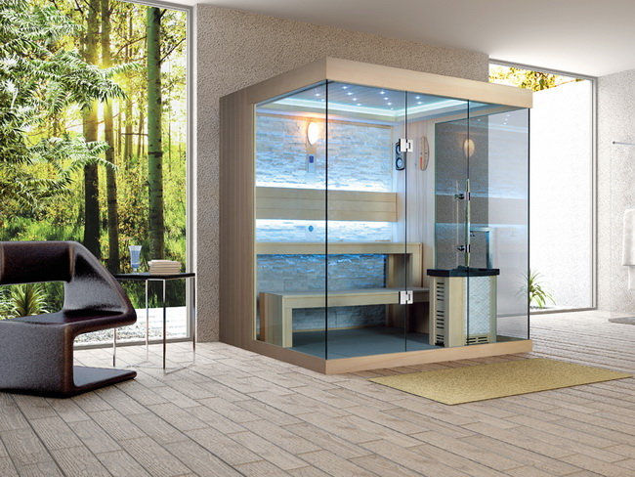
Model M010 200x180x210cm 220x180x210cm

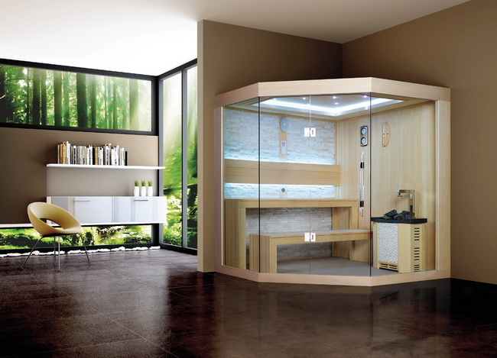

Model M011
200x180x210cm
220x180x210cm

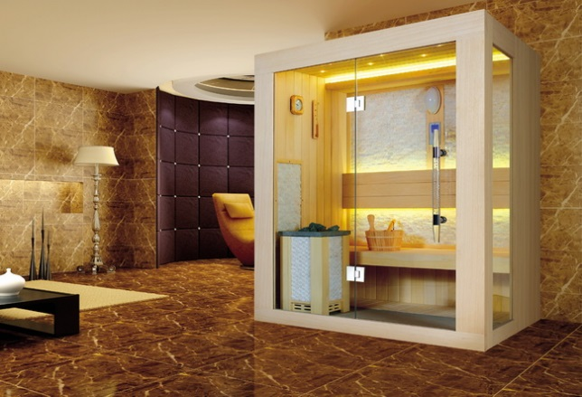
Model M012
100x110x210cm
120x110x215cm
150x110x215cm

www.abcbath.com Tel:222553531 Tel:506607194
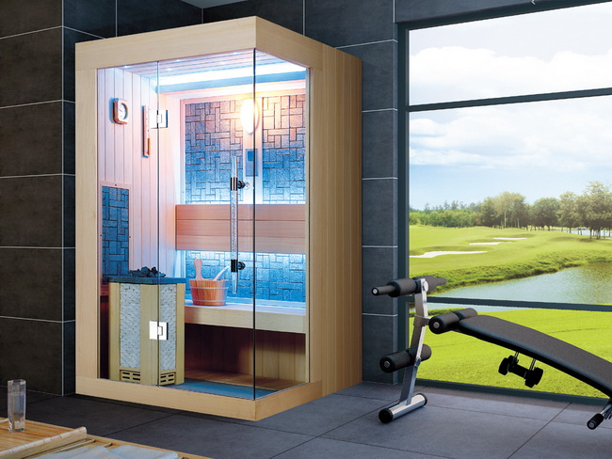
Model M013
100x110x215cm
120x110x215cm
150x110x215cm

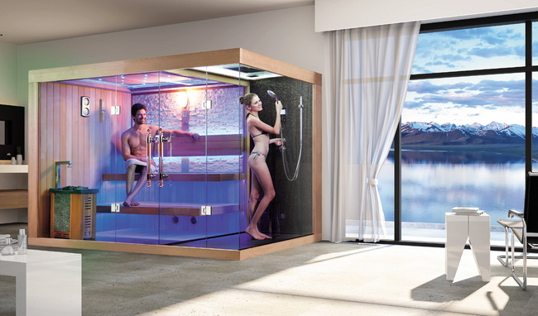

Model M014
200x120x210cm
220x120x210cm
250x180x210cm
300x180x210cm
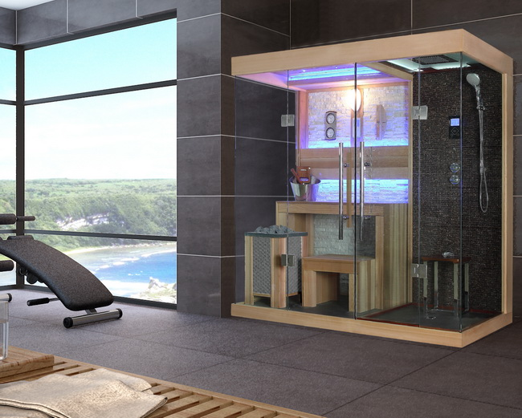
Model M015
200x100x210cm
200x120x201cm
220x120x210cm

www.abcbath.com Tel:222553531 Tel:506607194
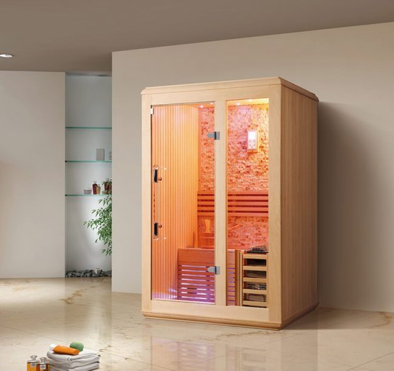
Model M016
180x107x190cm

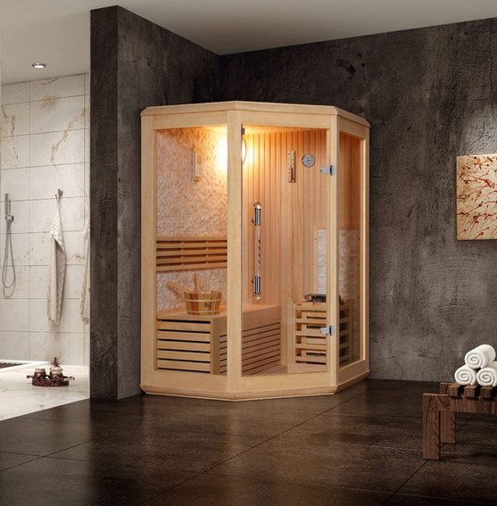
Model M017
160x160x190cm

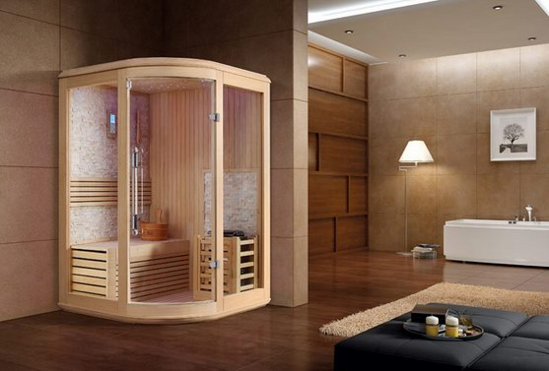

Model M018
150x150x190cm

www.abcbath.com Tel:222553531 Tel:506607194
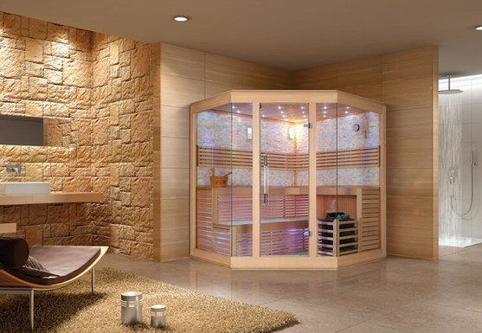
Model M019
220x220x210cm

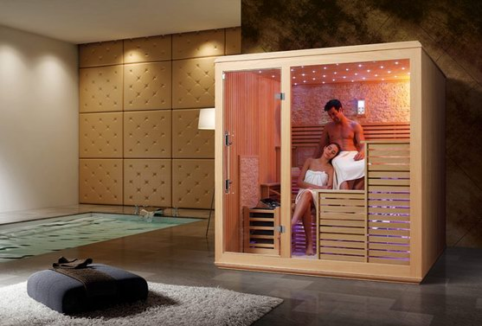
Model M020
220x170x210cm
Model M021
220x200x210cm
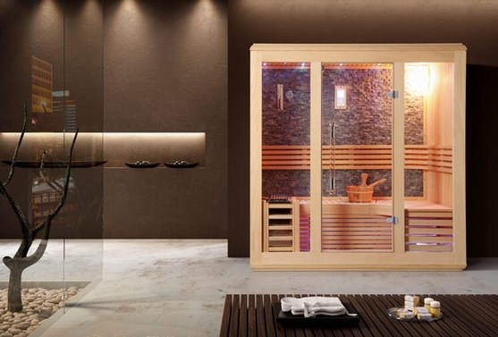
Model M022
200x120x210cm
200x150x210cm

www.abcbath.com Tel:222553531 Tel:506607194
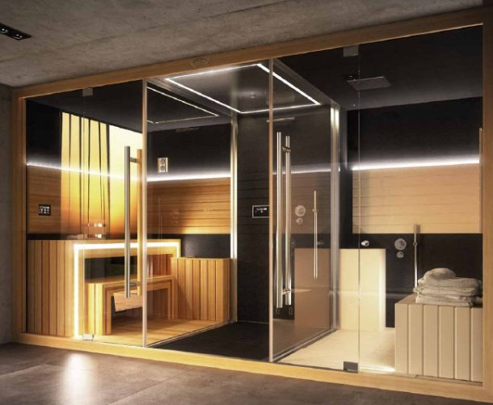
Model M024
380x163x220cm

