Sauny infrared
Model H001 Model H002 Model H006
130x120x200cm 110x110x200cm 90x160x198cm
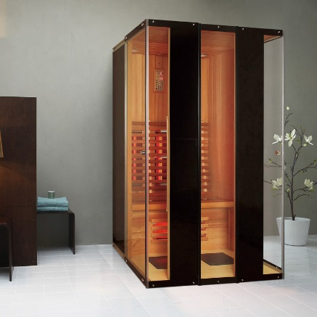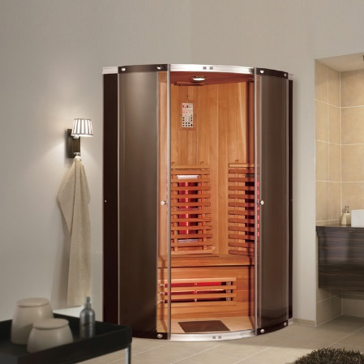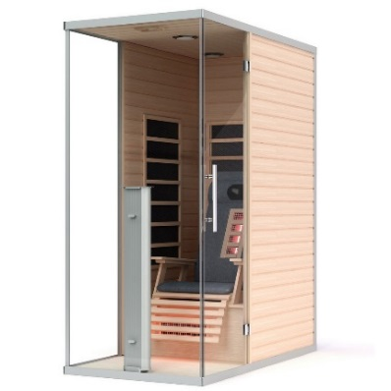

Model H007 Model H008 Model H009
160x160x198cm 110x100x200cm 110x96x200cm

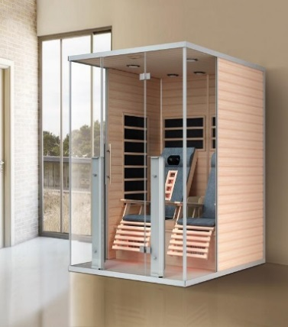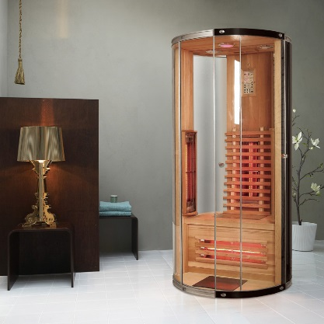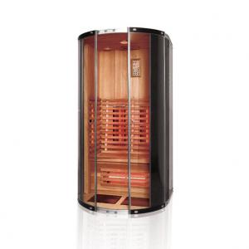
www.abcbath.com Tel:222553531 Tel:506607194
Model H010 Model H011 Model H012
210X140x200cm 150x150x200cm 130x130x200
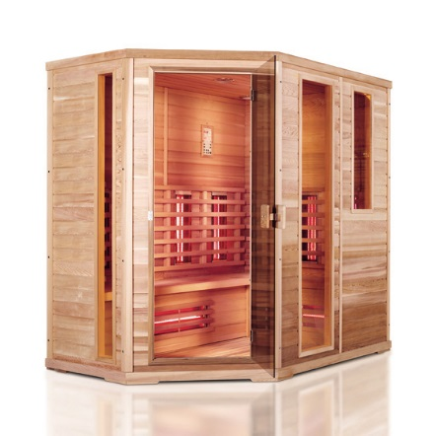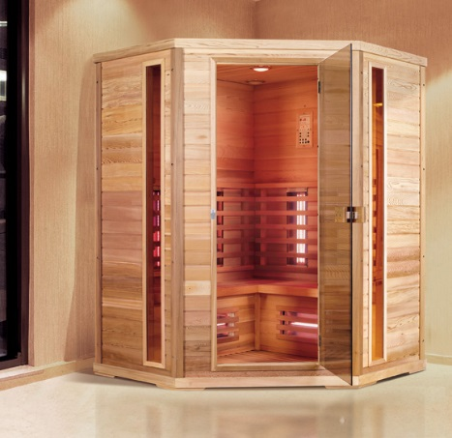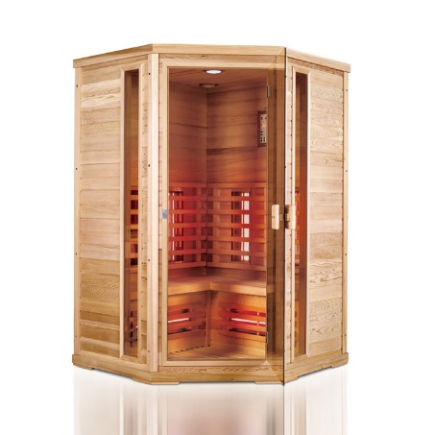
Model H013 Model H014 Model H015
119x101x198cm 149x101x198cm 149x101x198cm
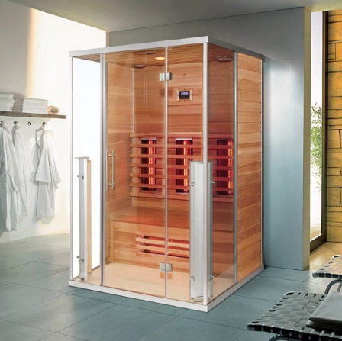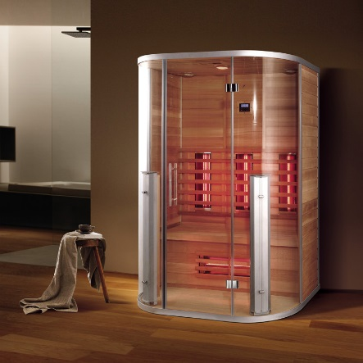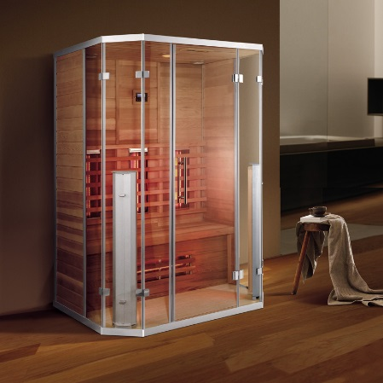

www.abcbath.com Tel:222553531 Tel:506607194
Model H016 Model H017
300x250x200cm 300x250x200cm
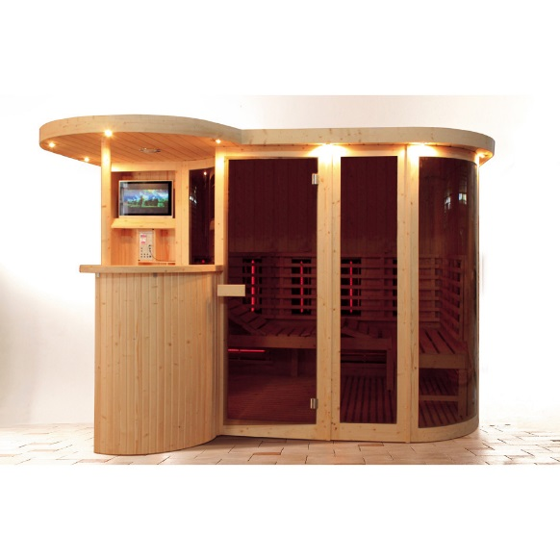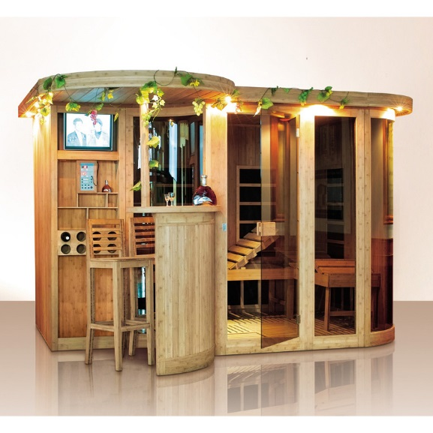
Model H018 Model H019 Model H020
100x100x200cm 127x100x200cm 100x100x200cm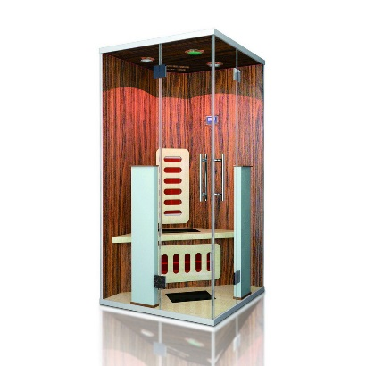 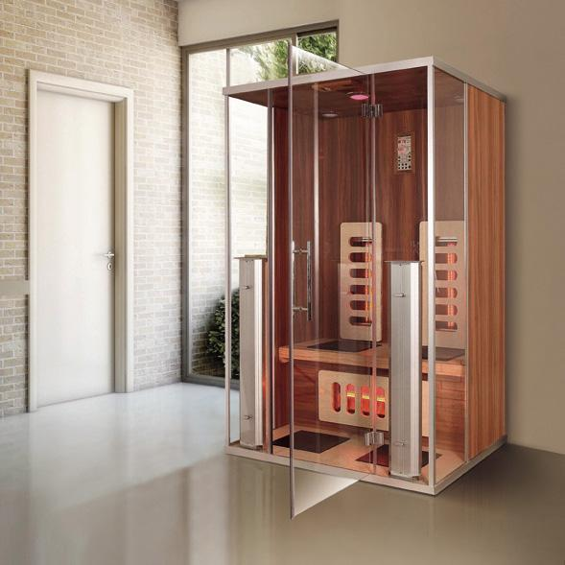 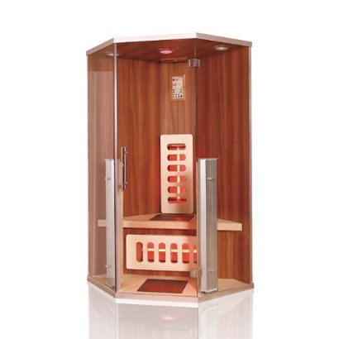

www.abcbath.com Tel:222553531 Tel:506607194
Model H021 MODEL H022 MODEL H023
150x100x200cm 135x105x200cm 170x170x200cm
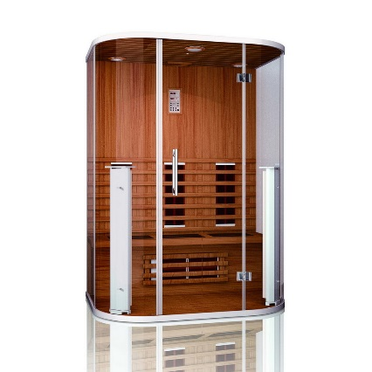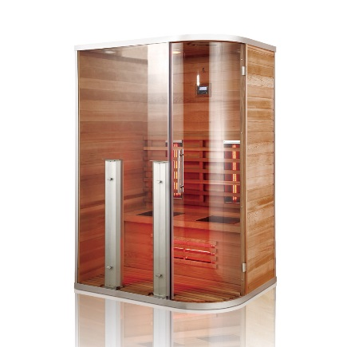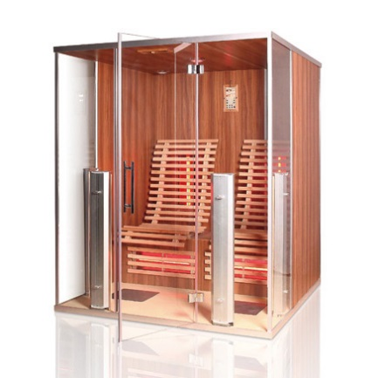
Model H024 Model H025
170x170x200cm 125x124x200cm
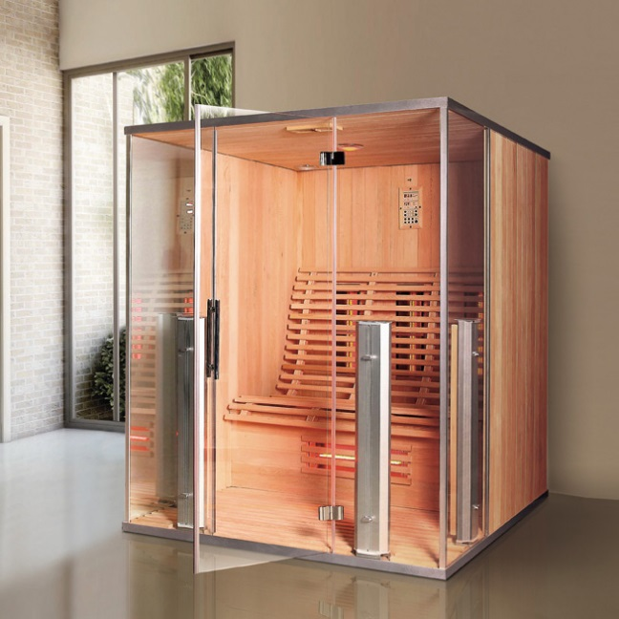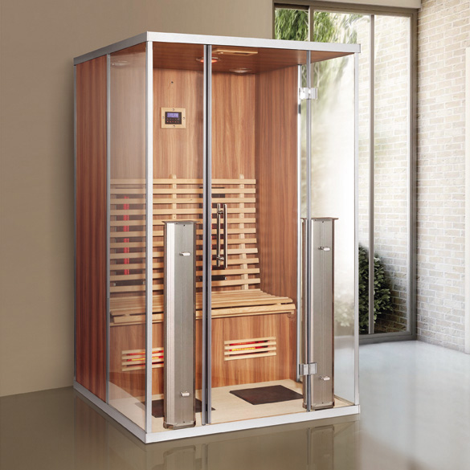

www.abcbath.com Tel:222553531 Tel:506607194

